

* ***Lord of healing and peace,***
* ***we pray for;***

*All who are mourning the loss of a loved one .*

***Bring them your healing and peace.***

*All who are suffering the impact of the difficult*

*family relationships, domestic abuse or divorce.*

***Bring them your healing and peace.***

*All who are in addiction and those in financial,*

*mental or spiritual turmoil .*

***Bring them your healing and peace***

* *All who are ill or recovering from illness;*
* *Jeannette, Anne & Ian, Leah, Alison, Annabelle*
* *and all who we know personally, who are suffering*
* *at this time in body, mind or spirit.*
* ***Bring them Your healing and peace.***

*All who care for a disabled, sick or elderly*

*loved one.*

* ***Bring them Your healing and peace.***
* ***“Peace I leave with you; my peace I give you.***

***I do not give to you as the world gives. Do not***

***let your hearts be troubled do not be afraid.”***

***John 14:27***

**May 2025: The Season of Easter**

**Prayer letter**



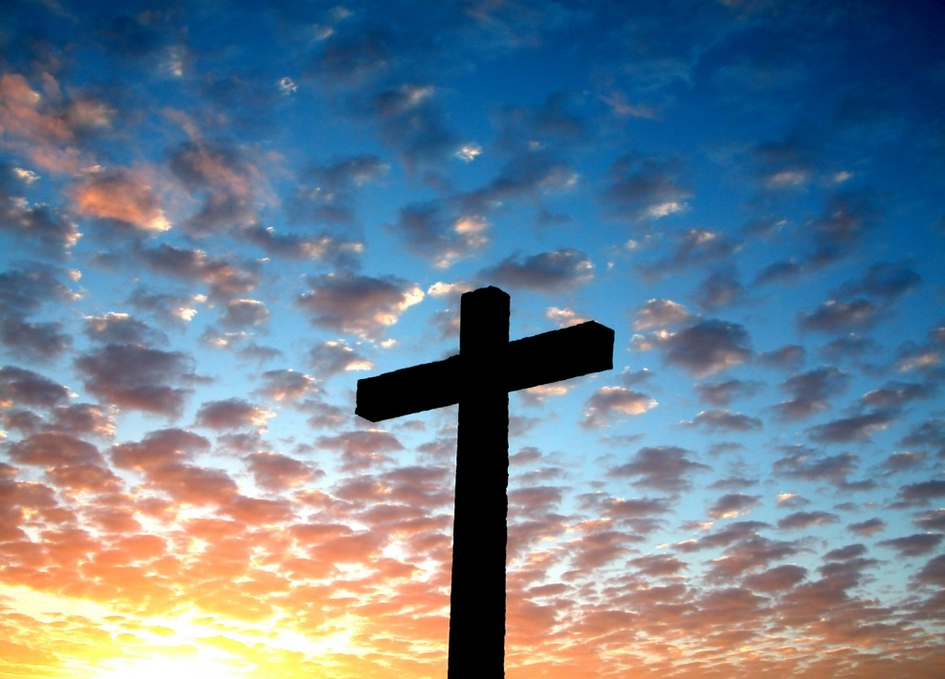

**He is Risen!**

;;



***“I pray that the eyes of your heart may be enlightened in order that you may know the hope to which he has called you*** *,* ***the riches of his glorious inheritance in his holy people,******and his incomparably great power for us who believe.”***

***Ephesians 1: 18-19***



***Thank You Lord Jesus for the hope and renewal***

***which the season of Easter brings!***

***“For God so loved the world that he gave his one***

***and only Son, that whoever believes in him shall***

***not perish but have eternal life”***

***John 3:16***

***We pray Lord Jesus;***

*For the renewal of faith in You, our loving God, by the people of our nation and of all nations of our world.*

*For the restoration and maintenance of the infrastructure & services which are so important to the health and well being of all of us.*

*For the restoration of rivers, oceans and critical ecosystems*

*so badly damaged and made vulnerable by our lack of care*

*for the amazing life filled world you gave us to be stewards over.*

***We pray Lord Jesus;***

***For compassion and care for the most vulnerable amongst us***

***in our nation and around our troubled world,***

***we bring before You;***

* *The sick the disabled and the down trodden*
* *Those who have survived the horror of war and those*

*still suffering ongoing war in Ukraine, Myanmar, Gaza, Israel*

*Yemen and in many other parts of our troubled world.*

* *People fleeing war, persecution and famine as refugees or*

*asylum seekers.*

* *The millions of Christians around our world who*

*face persecution, torture and death simply for their*

*faith in You, our loving and eternal God.*

***Lord hear us as we pray for;***

* Bishop Philip, Bishop Joe and Bishop Gill in the Diocese of Blackburn.
* All the Clergy of our Church and their families**,** for our Vicar Dave, for LJ and for all who assist and support them in their Ministry.
* Steve and Lisa, for their Ministry here and in India.
* Our Church Wardens and those who support them in many practical ways & all who minister to the sick, the homeless and housebound.
* Marlis in her missionary work overseas.
* Vicky as her placement at St Nicholas’ at Fleetwood.
* Glyn and all others who faithfully serve in our worship group.
* All who serve us with refreshments which they provide for us to enjoy together in our church.
* All who come to St Thomas’ in worship or seeking support or prayer and for all who live in or visit our town.
* All who serve on our PCC and for all others who serve in

important but often unseen ways.

* Those who live or work in our Parish and in our town.



***We remember in prayer***

All who served our nation during World War Two, on the home front, in our Armed forces on land, sea and in the air, and for those in our Merchant Navy who brought vital supplies and equipment to our nation, to our armies and our allies across many dangerous oceans.

***We thank you dear Lord*** that through their courage and sacrifice, and alongside our allies from many nations, **together, they brought Victory in Europe on 8th May 1945 -** Freeing the people of our continent from the evils of Nazi fascism, **to bring the peace our nation and our European neighbours enjoy to this day.**

***We also pray*** that we will all soon live in a peaceful world - Especially for our continent of Europe, that the horrors of the Russian/Ukraine war will soon end with a just and lasting peace.