

**Harvest**

**Prayer Letter**

2nd October 2022

* ***Lord of comfort and peace, we ask that you be with all those who suffer pain and anguish in bereavement; and for all who are struggling with infirmity or pain in body, mind or spirit.***

For those in hospital and at home;  
surround the frightened with Your tenderness;  
give strength to those in pain;  
hold the weak in Your arms of love, and give hope and patience  
to those who are recovering.

***We bring before You now***: Audrey, Sarah, Jack, Leah, Debbie, Stephen, Norman and Jean, Anne and Ian and all who we know by name who are suffering at this time.

***Especially at this time we remember Sue Waite. We thank you Lord for Sue's life of service and her compassion and kindness towards others. We also pray for Sue's family and friends in their grief.***

Thank you, Jesus. **Amen**

***"The Lord bless you and keep you.***

***The Lord make His face shine upon you and be gracious to you.***

***The Lord turn His face to you and give you His peace."***

**Numbers 6: 24-26**

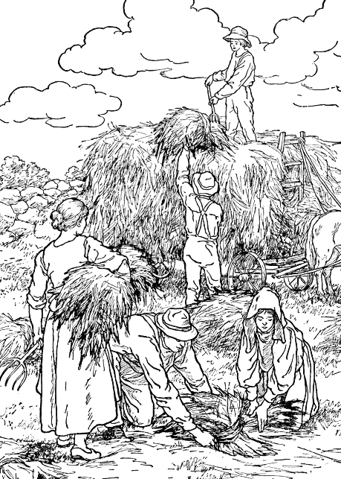

**Gift Day**

“Each of you should give what you have decided in your heart to give, not reluctantly or under compulsion, for God loves a cheerful giver. And God is able to bless you abundantly, so that in all things at all times, having all that you need, you will abound in every good work.” **2 Corinthians 9: 7-8**

Corinthians 6: 7-8

***Lord hear me as we pray,***

for all those is positions of power and leadership in every political party in Parliament and in local or devolved Government across the nations of the United Kingdom.

for our Emergency Services, Armed Forces and Frontline NHS and Social Workers. For all our fellow citizens who give their time as volunteers in service to help others in need or in distress, both in our nation and overseas.

for the people of our town and for all who visit for leisure and recreation and those who travel to and from Blackpool for their work.

for all who are anxious and afraid of the financial situations developing in our nation which may impact on them adversely.

**for the people of Ukraine and** **Russia** - Especially at this time people in Russia who are bravely protesting against the war, despite the threat of arrest, imprisonment and immediate drafting into the Russian armed forces against their will.

**for strength, unity and wisdom** in how the leaders of nations, particularly those whose nations are members of NATO respond to the threats to world peace which have been made by President Putin as his forces in Ukraine are in disarray.

for the people of Iran and in other nations where people are oppressed by totalitarian regimes

**We pray for the millions of Christians around our world** who face arrest, imprisonment torture and even death, simply for proclaiming You as their Lord and Saviour.

***Almighty God,*** wherever there is injustice and suffering caused by differences between people in our world, we pray for tolerance and an end to persecution by the powerful against the weak.

***Lord hear me as we pray,***

for all Church leaders across our nation, and in our parish for our Vicar Dave and for the work of Alison through Ashar and those attending Starting Point.

for Steve and Lisa in their mission with the poor in India and in our Parish.

for Matt and Rosie and everyone involved in helping in Matt's ministry with children and young people across our Parish. and those who have volunteered to help in upcoming work.

for all who attend our Church, that they may know your loving presence and accept You into their lives, knowing your love and forgiveness for each them.

for our Worship group in all they do both in their preparation and practice and in leading us in worship and praise through their music and singing.

**For King Charles III**

