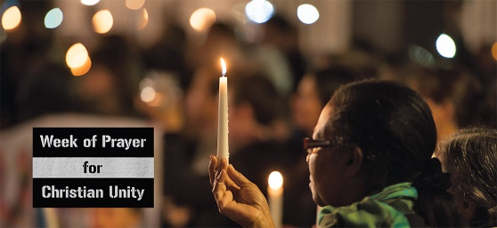
18th – 25th January
Churches Together in Britain and Ireland (CTBI) observe this week of prayer for Christian Unity
The theme this year is: Be-Longing: Praying for Unity amidst Injustice -
Seeking to explore how the work of Christian unity can contribute to the promotion of racial justice across all levels of society. A quote from CTBI:
“As we join with other Christians around the world for the Week of Prayer we pray that our hearts will be open to see and hear the many ways in which racism continues to destroy lives, and to discern the steps we can take as individuals and communities to heal the hurts and build a better future for everyone.”
Each year Christian Aid provides the Go and Do action points for each of the daily reflections (available through the CTBI website) – linking the important work of Christian Aid in the relief of poverty and advocacy of justice. One of the prayers from the daily reflections:
God of justice and of grace,
remove the scales from my eyes so
I can truly see the oppression around me,
and give me courage not only to name it,
but to fight it while providing authentic presence,
witness, and compassion to the oppressed. Amen.

Psalms for each day of the week 23rd – 28th January:
Mon: Psalm 108 Tues: Psalm 132 Wed: Psalm 66
Thurs: Psalm 47 Fri: Psalm 65 Sat: Psalm 68
The services for the coming weeks are given below.
Key: DOB: Revd Dave O’Brien; YB: Yvonne Blazey; VB: Vicky Bentley
DW: Revd David Wilkinson; TH: Thomas Henley; SH: Revd Steve Haskett;
CB: Chris Blazey
Holy Communion Service of the Word
SUNDAY | 10.30am | 6pm
22nd Jan  Epiphany 3 | Theme  Matthew 4: 12 -23  Lead: DOB  Preach: DW | Theme  Isaiah 61:1 - 3  The Promise of the Messiah  Lead: DOB  Preach: DW
29th Jan  Epiphany 4 | Theme:  Mark 4: 26 - 34  Lead: DOB  Preach: TH | Evangelistic Invitation  Theme:  Luke 4: 14 - 21  Lead: SH  Preach: DOB
5th Feb  3rd before Lent | Theme:  Colossians 1:  1-14  Matthew 5. 13-20  Lead: DOB  Preach: Bishop Jill | Theme:  Ezekiel 37.1-14  The Promise of Revival  Lead: DOB  Preach: CB
12th Feb  2nd before Lent | Theme: Colossians 1:  15 – 23  Matthew 6:25 - end  Lead: DOB  Preach DW | Theme:  Acts 4: 23 – 31  The Promise of Power ‘The Prayer that Shakes’  Lead; VB  Preach: YB
Midweek (Wed) Book of Common Prayer Holy Communion Service:
25th January  Matthew 19: 27 – end  Lead: DOB Preach: DOB | 8th February  Mark 7: 14 – 23  Lead: DW Preach: YB
1st February  Mark 6. 1 - 6a  Lead: DOB Preach: VB | 15th February  Mark 8: 22 – 26  Lead: DOB Preach: TH
22nd February ASH WEDNESDAY John 8: 1 – 11 Lead/Preach: DOB

