
Today we bless Revd Emma, Joa and Mikey on their way as they move to Emma’s new post as Mission Enabler with the Lytham Parish.
Please enjoy the refreshments after the 10.30am service and chat to Emma and the boys.
We thank God for the time we have spent together, for the services Emma has taken, for the work she has done on the church website and the morning prayers she has done throughout the last 2 years. May our Lord richly bless Emma, Joa and Mikey in this new season. Thank you Emma for all your hard work!
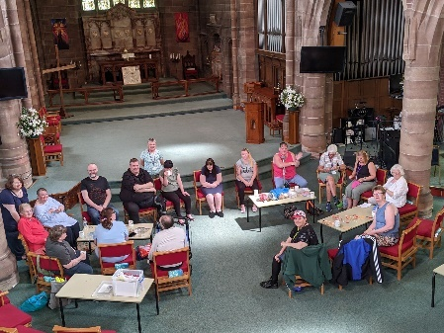
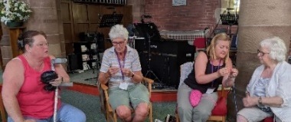
Here is Starting Point, (brew and a chat, Monday afternoons). For many months our dedicated prayer walking team have prayed around the parish. Starting Point are producing crocheted hearts which will be attached to cards with words of Christian encouragement and then put on benches around the area – ‘prayer’ benches. After the summer break, Starting Point will meet again on 5th September.
The services for the coming weeks given on the opposite page.
Key: CB: Chris Blazey; YB: Yvonne Blazey; SH: Revd Steve Haskett; DOB: Revd Dave O’Brien; ES: Revd Emma Swarbrick


Holy Communion Service of the Word



Prayers for healing Children’s Bible Study
during the service & Family Worship
Each SUNDAY | 10.30am Intergenerational Service | 3 – 4pm Children’s Bible Study  4 – 5pm Family Worship |  | 6pm Worship, Prayer and Bible Teaching
SUNDAY | 10.30am |  | 3 – 4pm and  4 - 5pm |  | 6pm
17th July  Trinity 5  Emma’s Farewell Sunday |   Luke 10: 38 – end  Preach: DOB  Lead: ES |  |  |  |   Luke 10: 38 – end  Preach: ES  Lead: DOB
24th July  Trinity 6 | Luke 11:  1 – 13  Preach: CB  Lead: DOB |  |  |  | Luke 11:  1 – 13  Preach: DOB  Lead: SH
31st July  Trinity 7 | Luke 12: 13 – 21  Preach: SH  Lead: DOB |  |  |  | Luke 12:  13 – 21  Preach: DOB  Lead: SH
7th August  Trinity 8 | Luke 12: 32 – 40  Preach: YB  Lead: DOB |  | “Love where you live”  Mission Launch  Joint Commissioning Service  at ST MARK’S (TRINITY PARISH) CHURCH  6PM  With Bishop Philip
Midweek (Wed.) Book of Common Prayer Holy Communion Service:
20th July | Luke 10: 38 – end Lead/Celebrant: DOB Preach: YB
Midweek Communion takes a summer break after this last Wednesday, restarting 7th September
Morning Psalms for each day of the week 18th – 23rd July :
Mon: Psalm 98 Tues: Psalm 106 Wed: Psalms 111
Thurs: Psalm 115 Fri: Psalms 30, 32, 150 Sat: Psalm 121

(the LORD said…) Now my eyes will be open and my ears attentive to the prayers offered in this place. (2 Chron, 7: 15)

