

The Annual Parochial Church Meeting: will be held tomorrow, Monday 17th April, in church at 7pm. There are vacancies for Churchwardens, Deanery Synod reps and PCC members – nomination papers are at the back of church. Please note that those nominated need to be on our Electoral Roll. All are welcome to attend the meeting, however, any voting can only be done by those registered on the Electoral Roll. Thank you.

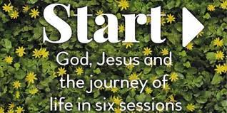
Those interested in joining the Start Course (What do Christians believe?), please have a chat to Revd Dave, thank you.
There will also be an After School club at Devonshire Academy starting in May being run by St Thomas’.

MISSION WEEKEND: Saturday 29th April BBQ and Fun Day.
Sunday 30th April George and Joan Fisher at 10.30am and 6pm services.
Please see fliers for details and please offer to help where you can.

The services for the coming weeks are given opposite.
Key to names of leaders and preachers : DOB: Revd Dave O’Brien;
DW: Revd David Wilkinson; VB: Vicky Bentley; YB: Yvonne Blazey

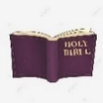

Holy Communion Service of the Word

SUNDAY | 10.30am | 6pm
16th April  EASTER 2 |   Theme:  John 20:19 – end  Lead/Preach: DOB |   Theme:  John 20: 24 – end  Lead: YB  Preach: DOB
23rd April  EASTER 3 | Theme:  Luke 24: 13 – 35  Lead: YB  Preach: DOB | Theme: John 21  Lead: DW  Preach:DOB
30th April  Easter 4  MISSION WEEKEND | Theme:  Psalm 84: 5-7  Colossians 3: 12 – 17  Lead: DOB  Preach:  Revd George Fisher | Theme:  Luke 9: 10 – 17  Lead: DOB  Preach:  Revd George Fisher

Midweek (Wed)Book of Common Prayer Communion Service at 11am:
19th April John 3: 16 – 21
Lead/Preach: DOB
26th April John 6: 35 – 40  Lead: DOB Preach: YB | 3rd May John 12: 44 – end  Lead: DW Preach: VB

Psalms for each day of the week 17th – 22nd April:
Mon: Psalm 4 Tues: Psalm 5 Wed: Psalm 11
Thurs: Psalm 15 Fri: Psalm 19 Sat: Psalm 23

