TONIGHT at 6pm in church – a special gathering in conjunction with Devonshire Academy Choir. Thomas, who is on placement with us through the Blackpool Ministry Experience and is also on the MPower programme, has arranged this evening together with Revd Dave and Devonshire Academy. A short time of song, praise and telling a story of faith.
Following on from this, an After School Club will be starting in May at the Academy run by St Thomas’.
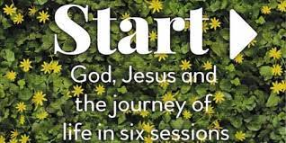
The Start Course (What do Christians believe?) will be run from Sunday 9th April at 4pm in Church. See Revd Dave for more details.
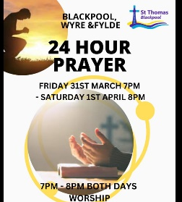
A big THANK YOU to all those who came to the 24 hour Prayer event this weekend and to all those who led each hour of prayer. Thank you to all those who prayed at home during the night and day. The greatest THANK YOU to God for all He gave and for all that is to come as He promised through this time of prayer. Please see the Prayer Letter for pictures and words received through this time and continue to pray for Blackpool, Fylde and Wyre and particularly the area we serve, the community around us.
GOOD FRIDAY – 7th April
Time of Prayer and Reflection
11am to 12 noon in church – 3 x 20 minute reflections before the Cross led by Thomas and Vicky. Please come and take time to journey with Jesus through His trial and suffering and crucifixion.
7pm to 9pm in church and in the community led by Revd Dave and the Worship Team. Reflecting on Jesus’ sacrifice for us.

MISSION WEEKEND Saturday 29th April BBQ and Fun Day.
Sunday 30th April George and Joan Fisher at 10.30am and 6pm services.

Annual Parochial Church Meeting: will be held on Monday 17th April in church at 7pm – please see the notices now in church.

As we enter Holy Week………

Psalms for each day of the week 3rd – 8th April:
Mon: Psalm 36: 5 - 11 Tues: Psalm 71: 1 - 14 Wed: Psalm 70
Thurs: Psalm 116: 9 - end Fri: Psalm 22 Sat: Psalm 31: 1 - 5

The services for the coming weeks are given below.
Key: DOB: Revd Dave O’Brien; DW: Revd David Wilkinson;
VB: Vicky Bentley; TH: Thomas Henley

Holy Communion
SUNDAY | 10.30am | 6pm
2nd April  PALM SUNDAY |   Theme:  Triumphal Entry  Psalm 118: 1 – 29  Matthew 21: 1 – 11  Lead: VB  Preach: DW | SPECIAL EVENING EVENT  Devonshire Academy Choir joining with our Worship Team for Palm Sunday.  Lead: TH/ DOB  ALL WELCOME
9th April  EASTER SUNDAY  CHRIST IS RISEN! | Theme:  Matthew 28:  1 – 10  Lead: DOB  Preach:DW | Theme:  Matthew 28: 1 – 20  Lead: VB  Preach: DOB

Midweek (Wed)Book of Common Prayer Communion Service at 11am:
5th April John 13: 21 – 32
Lead/Preach: DOB
12th April Luke 24: 13 – 35  Lead/Preach: DOB | 19th April John 3: 16 – 21  Lead/Preach: DOB

