

**Prayer Letter**

**16th April 2023**

* ***Lord of comfort and peace,***
* *we pray for all who are affected by the breakdown of family relationships, domestic abuse and divorce.*

***Lord of comfort and peace,***

*we pray for all who are struggling to escape from addiction, or from any form of physical, emotional or spiritual oppression.*

* ***Lord of comfort and peace,***
* *we pray for all who are lonely and for all who are struggling with infirmity or pain in body, mind or spirit. We bring before you in our prayers:*
* ***Sarah, Leah, Debbie, Stephen, Norman and Jean, Anne and Ian and all who we know personally who are suffering at this time.***
* ***"The Lord bless you and keep you.***

***The Lord make His face shine upon you and be gracious to you.***

***The Lord turn His face to you and give you His peace."***

**Numbers 6: 24-26**

**1st Sunday after Easter**



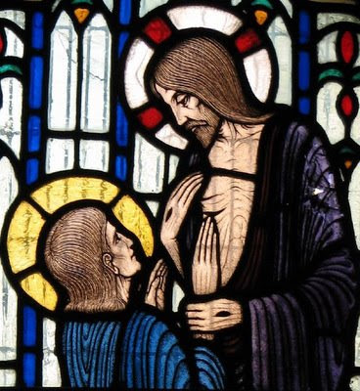



“Blessed are those who have not seen and yet have believed”

John 20:29

***Lord hear us as we pray,***

For peace and justice to prevail to bring a lasting and just peace for Ukraine and eventual reconciliation with their Russian enemy. Also, for the Russian people and other people around our world who live under the control of authoritarian regimes, that they may gain the rights and freedoms which the people of democratic nations enjoy.

For all who are fleeing persecution as refugees or asylum seekers - For their protection as they seek to escape and rebuild their shattered lives in places of welcome, safety, freedom and peace.

***For all who are persecuted because of their Christian faith, especially Christians in:***

* Afghanistan
* North Korea
* Somalia
* Libya
* Yemen
* Eritrea
* Nigeria
* Pakistan
* Iran
* India

***For our troubled and fragile world***, that there will be sustainable solutions urgently agreed and put in place by all industrial nations to slow down and eventually stop the rapid increase in global temperatures, which now threatens the beautiful and abundant world you have created for us to be stewards over. ***Amen***

***Lord hear us as we pray,***

**For all our Church leaders,** Including our Bishops Philip and Jill. In our parish, for our Vicar Dave, Alison and Josh and for Steve & Lisa, for their ministry in our Church and elsewhere, especially their ministry in India

**ForThomas,**as he continues his placement with us and elsewhere across Blackpool.

**For all in our worship group**, for their ministry in music, leading us in singing and praise to you.

insert text



***Lord hear us as we pray,***

**For all those is positions of power** and leadership across our nation and those who represent us in our town council and in Parliament

**For our emergency service workers**, guide them in their duties to act with integrity and courage. Keep them safe in situations of danger, as they work to keep us safe.

**For our Armed Forces** in their protection of our nation and also where ever they may be called to operate alongside soldiers of other nations to maintain or restore peace in our troubled world.

**For all who volunteer** across our nation. Especially at this time for all who give their time to serve others, provide life saving rescue and other vital but often unseen help to the most vulnerable.

**For our Doctors, Nurses, Social Workers, Teachers** and other key workers at these challenging times for themselves, their families and for our nation.

**For all who** struggle with increases in the cost of living and those whose businesses are in difficulty because of the many issues outside of their control.

**For all who live or work in our Parish,** that they may know your love for them and that they will come to know you as their Lord and Saviour.

***” You are my hiding place;  
You will protect me from trouble  
and surround me with songs of deliverance.”***

***Psalm 32:7***