
Lord of comfort, healing and peace,

- We pray for all who are struggling to cope, those affected by the breakdown of family relationships, domestic abuse and poverty .
We pray for all who are battling with addiction, or are suffering from any form of physical, emotional or spiritual oppression;
Lord of all hope, give them strength, courage and healing.

- Loving God, we ask for your blessing on all caregivers, those who give time and skills to bring hope and healing, at home, in hospitals, Care Homes and hospices.

Lord Jesus, we especially pray for all those on our Prayer Tree, those named in our service intercessions, those in our community who are ill and those we know personally who are suffering at this time.

We pray for all who are mourning the loss of a loved one:
Lord God, we pray for Your comfort and peace for all those who grieve and give us the wisdom to know how to minister to them.

"The Lord bless you and keep you.
The Lord make His face shine upon you
and be gracious to you.
The Lord turn His face to you and give you His peace."
Numbers 6: 24-26

Monthly Prayer Letter
OCTOBER 2025

The LORD says to His people:
‘I have the loved you with an everlasting love; I have drawn you with unfailing kindness’
Jeremiah 31 v 3

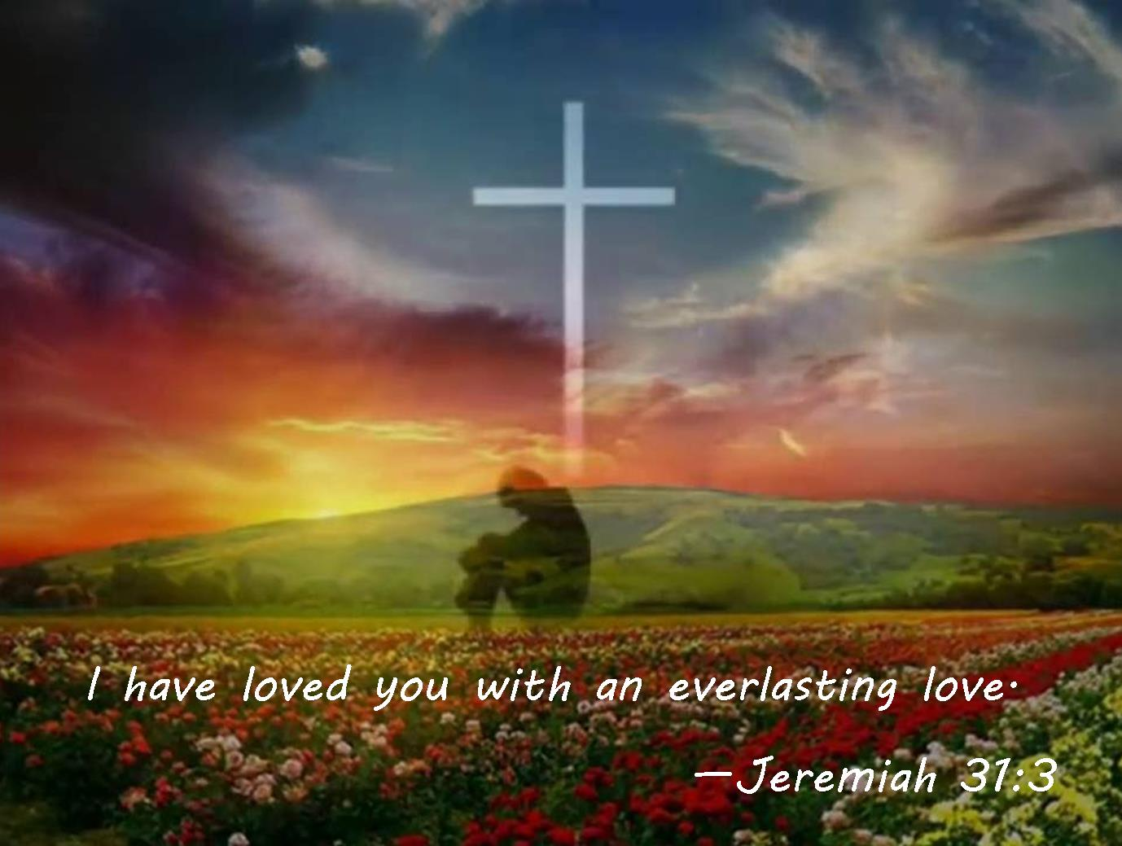

A Collect for Harvest
Creator God, you made the goodness of the land, the riches of the sea and the rhythm of the seasons;
As we thank you for the harvest, may we cherish and respect this planet and its peoples,
through Jesus Christ our Lord. Amen.

PRAYER TREE REQUESTS - please text John Smith on 07757 968574
Lord God, hear us as we pray for……….
1st the midweek Communion Service in our church today at 11am.
2nd our Vicar, Dave, on sabbatical. For Alison and Josh. Tuesday Church
meeting today, for Rev LJ and all the volunteers, children and families.
3rd someone we have met or remembered today.
4th the Harvest Ceilidh in the Parish Centre tonight. Remembering also the feast day of St Francis of Assisi – make me a channel of Your peace.
5th HARVEST SUNDAY and GIFT DAY
6th our PCC that meets tonight, for wisdom and vision.

The aim of this Prayer Letter is to help us pray through the month of October, day by day, holding before God the world, our parish community, events happening in the month, the church and ourselves.

19th our services today – morning Communion and evening Service of the Word, all those involved in leading, preaching, worship in music, intercessions and those who run the tech desk.
20th all those who work in our church office, answering phone calls and emails and looking after the administration duties.
21st all who work to ensure safeguarding is a priority in our church and all throughout the Diocese who work for the safety of children, young people and the vulnerable.

22nd someone we find hard to forgive or trust. Pray also for those who live on Ascot Road.
23rd the Toddler group, for the leaders and the families and thank God for the fellowship and witness of this group.
24th those bringing children for baptism and for our church team helping to prepare families for baptism.
25th those who live on Beresford Street. Those who look after the maintenance of our buildings, thanking God for their work, time and effort.
26th our services today of morning Communion and evening Service of the Word and for all those involved. Pray that each of us may come to the Lord afresh today and receive all that He has for us in worship. Remembering the clocks go back an hour !

27th the leaders, volunteers and those who come to Brew and a Chat this afternoon in church. Pray for listening and being heard.
28th Simon and Jude, apostles – feast day. Almighty God, You built your Church on the foundation of the apostles and prophets,
with Jesus Christ himself as the chief cornerstone: make us a holy temple acceptable to You. Amen.
29th ourselves – Heavenly Father, help us to grow in generosity of spirit, to have the mind of Christ and share Your love with all.
30th those who come to the warm space offered in church this afternoon with fellowship and activities. Remember in prayer our Family Engagement Worker, Nicola.
31st Jesus Christ is the Light of the World – a light no darkness can quench. Even the darkness is not dark for You; and the night shines like the day. Let Your light scatter the darkness and Your church with Your glory.

The people of Gaza: Lord, please bring relief to that region, food and supplies and a lasting peace. Heavenly Father, bless all relief workers and those striving for an end to war and destruction.

7th Rev David and Alison Wilkinson, for Rev Steve and Lisa in their work both in the Diocese in Parish Renewal and with Life Association.
8th someone who is hurting or lonely. Pray for those who live in Addison Crescent. Pray for the ministry of Ashar bringing Hope.
9th our Worship Team, thanking God for the gift of music.
10th those attending our Bereavement Group.
11th our Bishops Philip, Jill and Joe, for God’s wisdom and strength.
12th the church services today. The Welcome and Prayer Ministry teams.
13th the church leadership team, Rev LJ, churchwardens Pauline and Denise and the wardens team, and LLMs (Yvonne and Vicky).
14th our church cleaning team, the Holy Dusters; they meet to work and pray together every Tuesday.
15th a troubled situation that is on our hearts and for all those who minister in pastoral care.
16th those who serve in our gardening team, looking after the church grounds and the allotment.
17th those who live in Althorp Close and Kytson Close.
18th the witness of St Luke the Evangelist, whose feast day is today. Gospel writer, friend and helper to Paul on his missionary journeys.

Father God, We pray that the leaders of all nations come to know the truth and turn to You and work for the peace and security of our troubled and endangered world which you gave us to be stewards over for this and all generations which may follow us. In the name of Jesus, Amen.

We pray for all those who have been and continue to be affected by the war in and around Ukraine: Lord God, bring about Your lasting and just peace, enable the rebuilding of lives and country. Bring Your healing by the power of Your Holy Spirit. In Jesus’ name. Amen,.

