

**Prayer Letter**

**30th April 2023**

* ***Lord of comfort and peace,***
* *we pray for all who are affected by the breakdown of family relationships, domestic abuse and divorce.*

***Lord of comfort and peace,***

*we pray for all who are struggling to escape from addiction, or from any form of physical, emotional or spiritual oppression.*

* ***Lord of comfort and peace,***
* *we pray for all who are lonely and for all who are struggling with infirmity or pain in body, mind or spirit. We bring before you in our prayers:*
* ***Katherine, Leah, Debbie, Stephen and Lisa, Norman and Jean, Anne and Ian and all who we know personally who are suffering at this time.***
* ***"The Lord bless you and keep you.***

***The Lord make His face shine upon you and be gracious to you.***

***The Lord turn His face to you and give you His peace."***

**Numbers 6: 24-26**

**4th Sunday of Easter**



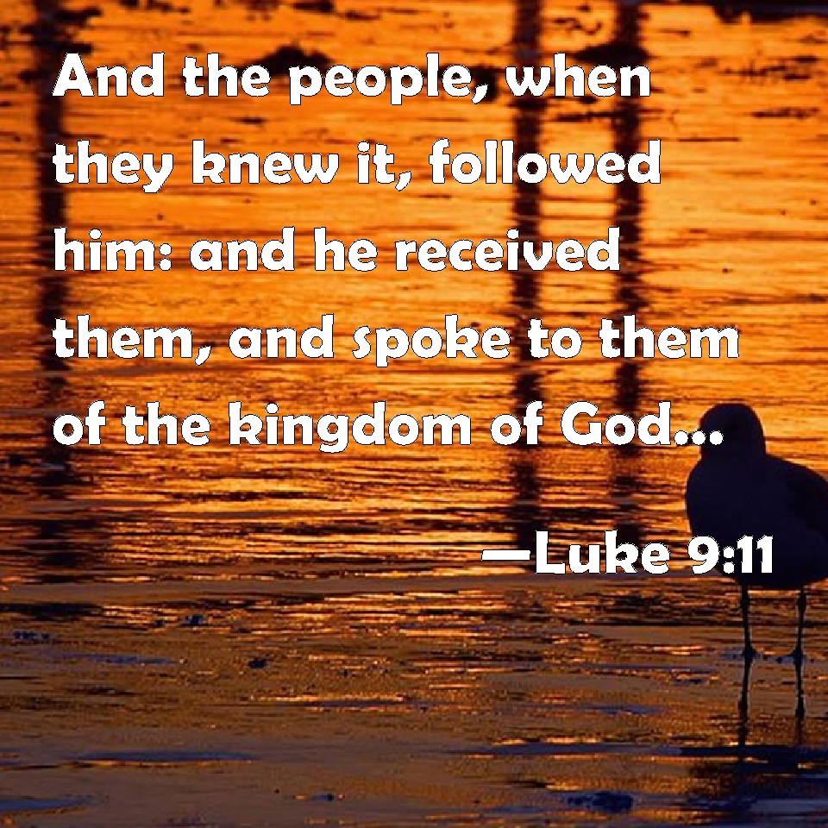



***Lord, hear us as we pray,***

For peace and justice to prevail to bring a lasting and just peace for Ukraine and eventual reconciliation with Russia.

For a successful conclusion of the peace talks between opposing forces in Yemen to end the war - That there will be a lasting and just peace for the suffering people of that nation after years of civil war.

For the people of Myanmar and Sudan where violence and civil war is raging with many innocent civilian casualties reported – In the case of Myanmar, often by deliberate targeting of villages by the Regime’s Air Force. In the case of Sudan – pray for all those fleeing the violence and devastation.

For all who are fleeing persecution as refugees or asylum seekers - For their protection as they seek to escape and rebuild their shattered lives in places of welcome, safety, freedom and peace.

***For all who are persecuted because of their Christian faith, especially Christians in:***

* Afghanistan
* North Korea
* Somalia
* Libya
* Yemen
* Eritrea
* Nigeria
* Pakistan
* Iran
* India

***Amen***

***Lord, hear us as we pray,***

**For all our Church leaders,** Including our Bishops Philip and Jill. In our parish, for our Vicar Dave, Alison and Josh and for Steve & Lisa, for their ministry in our Church and elsewhere, especially their ministry in India.

**ForThomas,**as he continues his placement with us.

**For George and Joan** as they come to join us in Mission and for our services of worship.

**For all those who work in our church** – for teams active, for example, in worship leading, cleaning, gardening, hospitality, pastoral care, Starting Point (brew and a chat) and hall hire.

insert text



***Lord hear us as we pray,***

**For all those is positions of power** and leadership across our nation and those who represent us in our town council and in Parliament

**For our emergency service workers**, guide them in their duties to act with integrity and courage. Keep them safe in situations of danger, as they work to keep us safe.

**For our Armed Forces** in their protection of our nation and also wherever they may be called to operate alongside soldiers of other nations to maintain or restore peace in our troubled world.

**For all who volunteer** across our nation.

**For our Doctors, Nurses, Social Workers, Teachers** and other key workers at these challenging times for themselves, their families and for our nation.

**For all who live or work in our Parish, those who visit our Church and for all who came to the Fun Day:** May they come to accept You, Jesus, into their lives, to believe and trust in You as the risen and living God, our Saviour Christ, King of Heaven and Earth!

**Lord, hear us as we pray for Marlis:** For the Mission work she is undertaking with Interserve International in Asia.

***” You are my hiding place;  
You will protect me from trouble  
and surround me with songs of deliverance.”***

***Psalm 32:7***