CHANGE TO THE EVENING SERVICE ON Sunday 11th December - Devonshire Academy Choir are coming to sing at 5pm and we will be having our Christmas Tree lighting that evening too, followed by refreshments. PLEASE NOTE THE CHANGE OF TIME – 5pm not 6pm.
Help needed to set up church – please see Pauline
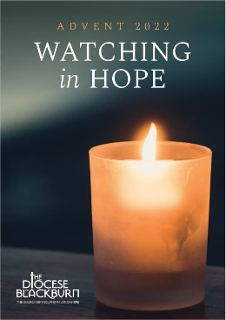
As advertised in last week’s newsletter, this Sunday (27th November) is the start of the Advent season. A time of preparation to get ourselves spiritually ready to celebrate the coming of Christ at Christmas-time. The Diocesan study guide – Watching in Hope is available in church and online. Please do use this guide in your personal quiet time and in the small groups.
The daily study begins with the scripture from Deuteronomy 30 ‘Choose life so that you and your descendants may live, loving the Lord your God, obeying him, and holding fast to him; for that means life to you and length of days.’ (v 19b – 20a)

A reminder that the funeral of Jack Hull will be held in church on Monday 12th December at 11.00am, followed by a service of committal at Carleton Crematorium at 12.30pm.

Psalms for each day of the week 28th November – 3rd December:
Mon: Psalm 71 Tues: Psalm 74 Wed: Psalm 19 v 1 - 6
Thurs: Psalm 18 Fri: Psalm 17 Sat: Psalm 27

The services for the coming weeks are given opposite.
Key: DOB: Revd Dave O’Brien; SH: Revd Steve Haskett; DW: Revd David Wilkinson; VB: Vicky Bentley (LLM); YB: Yvonne Blazey (LLM);
CB: Chris Blazey; IL: Irene Leak
Holy Communion Service of the Word

Prayers for healing
during the service
SUNDAY | 10.30am | 6pm
27th Nov.  ADVENT 1 | 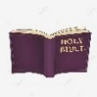  Matthew 24:  36 – 44  Preach: DOB  Lead: YB | Worship and Bible Teaching  Matthew 24:  36 – 44  The Coming King  Preach: VB  Lead: DOB
4th Dec.  ADVENT 2 | Matthew 3: 1 -12  Preach: VB  Lead: DOB | 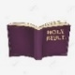  Prayer and Worship Gathering  Intercessory Prayer  Luke 1: 46 – 55  The Humble King  Preach: CB  Lead: DOB
11th Dec.  ADVENT 3 | Matthew 11: 2 – 11  Preach: DW  Lead: DOB | 5pm School Choir  CHRISTMAS TREE LIGHTING  John 18: 28 – 40  The Servant King  SH/IL
18th Dec  ADVENT 4 | Matthew 1: 18 –25  Preach:  Archdeacon Mark Ireland  Lead: DOB | Service of the Word  7 Lessons and Carols  Gospel Presentation  Theme: John 1: 1 – 14  The Word made flesh  Preach:  Archdeacon Mark Ireland  Lead: DOB
Midweek (Wed.) Book of Common Prayer Holy Communion Service:
30th Nov. St Andrew | Matthew 24: 36 – 44 Lead/Preach/Celebrant: DOB
7th Dec. | Matthew 3: 1 – 12 Lead/Celebrant: DOB Preach: YB
14th Dec. | Matthew 11: 2 – 11 Lead/Preach/Celebrant: DOB
Christmas break – this service will then recommence 4th January 2023

