
15th October 2023

Prayer Letter

- Lord of comfort and peace,
- we pray for all who are affected by the breakdown of family relationships, domestic abuse and divorce. Also, for those in addiction and those in mental or spiritual turmoil.

- we pray for all who are lonely and for all who are ill and those recovering from illness. We bring before you in our prayers:

- Irene, Leah, Debbie, Stephen and Lisa, Ted, Alison, Norman and Jean, Anne and Ian, Joe and Sue, and all who we know personally who are suffering at this time in body, mind or spirit.

- "The Lord bless you and keep you.
The Lord make His face shine upon you and be gracious to you.
The Lord turn His face to you
and give you His peace."

Numbers 6: 24-26

Praying for the World, especially, at this time,
Israel and Gaza
;;K

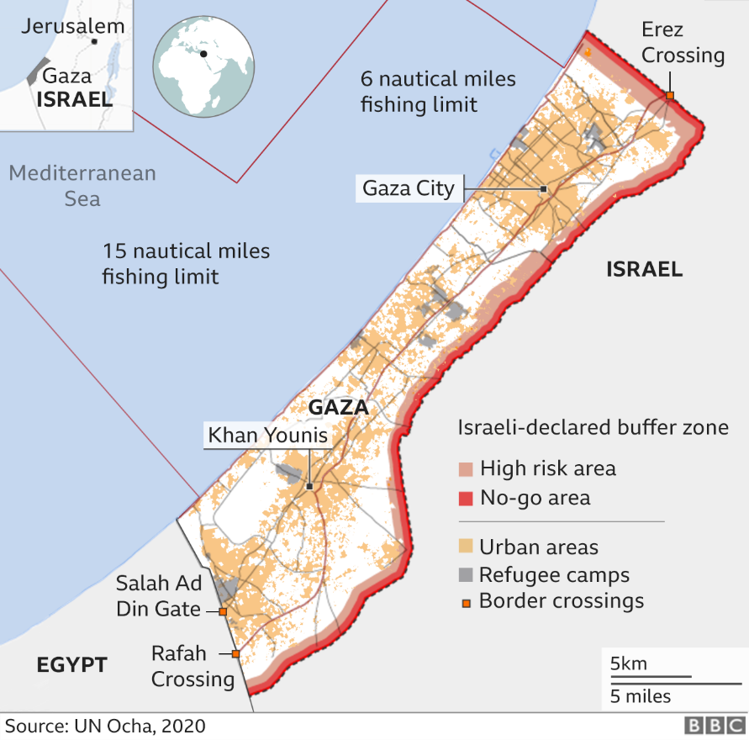

“But as for me, I am poor and needy; may the Lord think of me. You are my help and my deliverer; you are my God, do not delay.” Psalm 40 v 17
Lord, hear us as we pray,

- for all church leaders in our country and in our area of Blackpool and Lancashire. We hold before You, Lord God, Bishops Philip and Jill in our Diocese, praying that You give them strength and wisdom as they lead your people to grow in faith and service.
- for our leadership here at St Thomas’, for Revd Dave, Alison ad Josh, For our curate Revd LJ and for Revd David. And Alison as they minister with us.
- for Revd Steve and Lisa Haskett and for their work and ministry not only in Parish Renewal in our Diocese but also in their work in India, building up Your people there and working for the Gospel in the poorest areas.
- for Nicola, our Church Warden, and all the members of the PCC – Lord, give them wisdom and courage in their discussions and decision-making. We pray for such an outpouring of Your Holy Spirit to make us all courageous and loving in our ministry here.
- for all those who work quietly and tirelessly to maintain not only the church buildings and grounds but also to prayer walk our community, to give hospitality and to show love in meeting the needs of the congregation and the community.
Statements on the violence in Israel and Gaza.
First from the Archbishops of Canterbury and York:
“We are grieved and deeply concerned at the violence in Israel and Gaza, and we unequivocally condemn the attacks by Hamas. We pray for those who are mourning, those who are injured, and all those fearing for their safety. We pray for restraint on all sides, and renewed efforts towards a just peace for all. The way forward must be for both sides to build confidence in a secure future through which Israel and its people can live in security within its internationally recognised borders, and Palestinians have their own state and live in their lands in security, and with peace and justice.”

And from our own Diocese of Blackburn:
Bishop Jill and I have been deeply moved and saddened beyond words by what we have all watched unfold in Israel and Palestine these last few days.

We therefore ask the Diocese of Blackburn to join us in prayer for peace in that place and an end to the violence which has led already to the loss of so many innocent lives.

Pray also to the God who calmed the storm to be at work in the hearts of those immediately involved in making decisions regarding what to do next, so that they might choose peace over perpetual bloodshed. Finally, pray for God’s wisdom to be found in those who advise leaders across the Middle East and wider world as they consider how to respond. +Philip Blackburn

Lord, hear us as we pray,
A collect for peace
Almighty God,
from whom all thoughts of truth and peace proceed:
kindle, we pray, in the hearts of all, the true love of peace
and guide with your pure and peaceable wisdom
those who take counsel for the nations of the earth
that in tranquillity your kingdom may go forward,
till the earth is filled with the knowledge of your love;
through Jesus Christ your Son our Lord,
who is alive and reigns with you,
in the unity of the Holy Spirit,
one God, now and for ever. Amen.

Lord, hear us as we pray,

For all those is positions of power and leadership. For our King and for all those in Government. Also, for all who represent us elected political positions in our town and across our nation.

For our emergency service workers and our nurses and doctors, guide them in their duties to act with integrity, skill and courage in whatever situation they may face.

For all who work in providing education to children, young people and adults in our Schools, Colleges and Universities.

For concerted action to identify and tackle the causes of knife crime amongst young people across our nation, which is causing so much suffering and grief to those impacted by it so frequently.

For all who work or volunteer in service to the poor, the hungry and the voiceless

