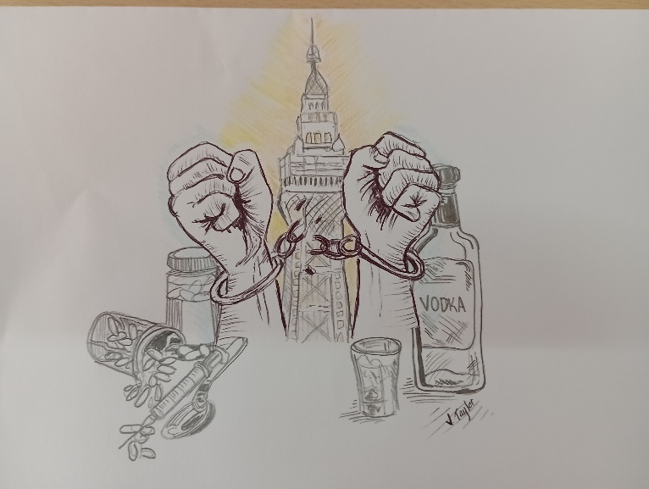
SOMEWORDS AND PICTURE

Prayer Letter

2nd April 2023
RECEIVED DURING
THE 24 HOUR PRAYER EVENT
31st MARCH – 1st APRIL
(shown here and inside):
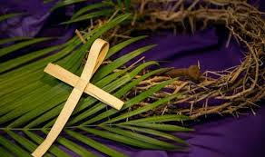
Faithful children I see your hearts,
I hear your cry, your prayers.
I am already moving.
You see the fruit
beginning to form in some areas.
But are you ready for me
to rattle the heights?
Yes, I believe you are, Do you?!
There will be many tears,
not all from sadness. The streets will be light again.
A new dawn is coming because of your faithfulness. I will, I will, I will.
(1) Beneath the lights there’s darkness, Lord. (2)But that’s through eyes of
Streets of shame and hurt and fear. discontent
Lives lost in deep despair Eyes that only see the worst
Brokenness beyond repair. Eyes that only see the darkness
Eyes blinded by deceit.

3) But Lord You see a different sight (4) Lord, You call us to this place
Hearts that long to be released to reach the lost with saving grace
Lives in sadness needing cure to show the love of Jesus here
Nothing here beyond repair. to vanquish heartache, sadness, fear.

PALM SUNDAY

Lord of comfort and peace,
- we pray for all who are affected by the breakdown of family relationships, domestic abuse and divorce. For all who are struggling to escape from addiction, or from any form of physical, emotional or spiritual oppression.

A Special Prayer for Palm Sunday
True and humble king
hailed by the crowd as Messiah:
grant us the faith to know You and love You,
that we may be found beside You
on the way of the Cross,
which is the path of glory. AMEN.
Lord hear us as we pray,

For all Christians in Blackpool, for unity among all who declare Jesus Christ is Lord. May the power of the Holy Spirit to inspire all believers to share the word of God and the love of Christ.
For those who work especially in areas of conflict or in places where there is severe personal danger for the good of others in our nation.
Fore more workers of all backgrounds for the plentiful harvest fields across Lancashire and for intercessors who are ambitious, insightful and who storm the gates of heaven.

- Lord of comfort and peace,
we pray for all who are lonely and for all who are struggling with infirmity or pain in body, mind or spirit, for Sarah, Leah, Debbie, Alison, Ted, Jude, Mary and Keith, Steve and Lisa, Norman and Jean, Anne and Ian and those who we know personally are suffering.
Lord hear us as we pray,
Our Diocesan prayer for Ukraine:
Almighty God, seated above all the affairs of humankind and sovereign over nations and leaders, hear our prayer for Ukraine at this time of war; that lives may be spared, that national boundaries be respected and that forces of aggression be restrained. Grant, Lord God, peace in your world in our time. Through Jesus Christ our Lord, Amen.
for those people in the other areas of our troubled world where conflict, poverty and famine are prevalent, and where so many cry out for justice and peace.
for the people of Iran, especially those who have been condemned to death and the families of those who have been brutally executed by the regime, simply for daring to protest for the freedoms and rights which we take for granted.
for refugees and asylum seekers, that they are treated with dignity, compassion and fairness within the law, wherever they seek refuge or asylum.
PRAYERS FOR TURKEY AND SYRIA
For all those affected and continuing to be affected by the earthquakes – for all those who lost loved ones, for those who lost their homes and are left with so very little. For the orphans and the widows. For those continuing to work tirelessly to bring relief and restore order. Almighty God, we pray for Your strength, for Your justice and for Your restoration. Only You, Lord, only You give life and hope.
For the people of Taiwan, where military tensions continue to build - That there will be a lasting peaceful resolution and de-escalation of the situation and also throughout the international waters of the South China Sea and its islands.
For all who are persecuted because of their Christian faith, especially at this time for Christians in China where the severe restrictions upon Christians to meet and worship have been further increased in the past week by the regime.
For our country, region and for Blackpool
For all who continue to struggle with increases in the cost of living or increases in their mortgage, rent or business costs.
For all those who work in our economy, solving financial problems and those working to make our country, our region and our town better places to live.
For those is positions of power and leadership across our nation in national government, in parliament, in local councils, in devolved governments and the mayors of regions around our nation.
For all those seeking to create employment and improve the living standards of all our citizens.

In response to Jonah 4: 10 and 11 read out during the 24hour Prayer Event:
I, the Lord, says to his Church you are concerned for this town, about this people and about these issues, even though you do not know the people, still your heart desires they come to know Me.
These people will come, they will fall to their knees and your prayers will be answered. (there is more and, as we go to print, the Prayer Event continues)
(we also heard again the words (the LORD said…) Now my eyes will be open and my ears attentive to the prayers offered in this place. 2 Chron, 7: 15)

Lord hear us as we pray,
- for all Church leaders across our nation, and in our community. In our parish, for our Vicar Dave, for Alison and Josh.
- for Steve and Lisa and for their ministry in our Church and elsewhere, especially for their work with the Life Association in India.
- for Thomas as he continues his placement with us.
- for all those who work to support our church services and all the activities that go on in church and the parish centre.

