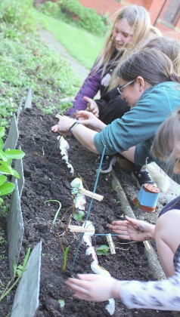
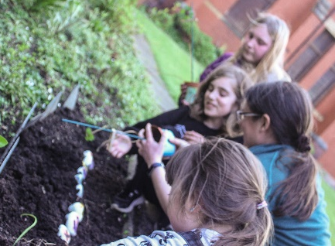
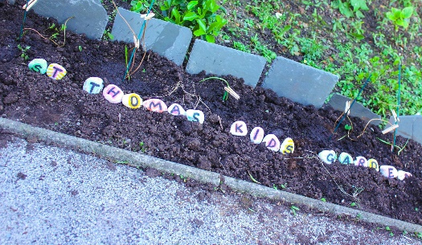
Planting for the future…. Some time ago our young people planted flower seeds and bulbs in pots that were placed on the window ledge at the back of church. This was done in trust that the seed or bulb would flourish within the soil and then begin to show above the ground as a plant or flower. The youngsters have waited patiently, and it seemed for a while that nothing was happening. We talked in a service about the roots developing and then nourishing the plant as it grew. For us as Christians it is not a big leap to see the connection between the sowing of seeds and taking care of young plants and the sowing of the Gospel by telling others about Jesus – taking care of and discipling new Christians and seeing the Kingdom of God grow – our job is to tell others about Jesus and let the Holy Spirit do His work. THANK YOU to Jasper for taking these photos as the flowers were planted in the grounds and became the ‘St Thomas Kids Garden’.
How appropriate is that on this MISSION WEEKEND? A huge ‘Thank You’ to George and Joan Fisher for being with us and to all those who helped in any way on the Fun Day (Saturday 29th).
We pray for God’s blessing on all the conversations and activities that happened yesterday. Praying for the Holy Spirit to work in every person in our community who has heard about Jesus and bring them to faith in Him.
The services for the coming weeks are given opposite.
Key to names of leaders and preachers : DOB: Revd Dave O’Brien;
DW: Revd David Wilkinson; VB: Vicky Bentley; CBr: Chris Brambles; YB: Yvonne Blazey; IL: Irene Leak
Holy Communion Service of the Word
SUNDAY | 10.30am | 6pm
30th April  Easter 4  MISSION WEEKEND | Theme:  Psalm 84: 5-7  Colossians 3: 12 – 17  Lead: DOB  Preach:  Revd George Fisher | Theme:  Luke 9: 10 – 17  Lead: DOB  Preach:  Revd George Fisher
7th May  Easter 5 | Theme:  The start of our series on  1 Corinthians  1 Corinthians 1:18 – 25  Lead: CBr  Preach: VB | Theme:  Luke 7: 1 – 17  Lead: VB  Preach/Preside: DW
14th May  Easter 6 | Theme:  1 Corinthians 3: 1 – 17  Lead/Preach: DOB | Theme:  John 6: 47 – 69  Lead: VB  Preach: IL
21st May  Easter 7 | Theme:  1 Corinthians  5: 1 – 13  Lead: YB  Preach: VB | Theme:  John 16: 5 – end  Lead: SH  Preach: YB

Midweek (Wed)Book of Common Prayer Communion Service at 11am:
3rd May John 12: 44 – end
Lead: DW Preach: VB

Psalms for each day of the week 1st – 6th May:
Mon (St Philip and St James): Psalm 119 v 1 - 8 Tues: Psalm 139 Wed: Psalm 119 v 57 – 80 Thurs: Psalm 118 Fri: Psalm 51 Sat: Psalm 68

