

**Prayer Letter**

**4th December 2022**

* ***Lord of comfort and peace,***
* *we pray for all who are affected by the breakdown of family relationships, domestic abuse and divorce.*
* ***Lord of comfort and peace,***
* *we pray for all who are struggling with infirmity or pain in body, mind or spirit,* ***for Sarah, Leah, Debbie, Stephen, Norman and Jean, Anne and Ian and all who we know by name who are struggling at this time.***
* ***Lord of comfort and peace,***
* *we pray for all those who are suffering pain, loneliness and anguish in bereavement.* ***We especially at this time thank you for the life of our friend and brother in Christ, Jack Hull*** *and for his faithful service at St Thomas’ and his kindness and compassion for others throughout his long life.*
* ***"The Lord bless you and keep you.***

***The Lord make His face shine upon you and be gracious to you.***

***The Lord turn His face to you and give you His peace."***

**Numbers 6: 24-26**

**2nd Sunday in Advent**

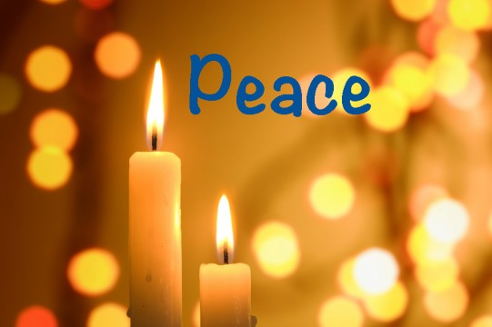

***Lord hear us as we pray,***

for all Church leaders across our nation, and in our community. In our parish, for our Vicar Dave and for the work of Alison through Ashar and all attending Starting Point on Monday afternoons.

for Steve and Lisa and all they do, both in our Church and elsewhere.

for Matt and Rosie and everyone involved in helping in Matt's ministry.

forThomasas he continues his placement with the Blackpool Ministry Experience at St Thomas’

for our Worship group in all they do both in their preparation and practice and in leading us in worship and praise through their music and singing.

for those who give their time in service to make our church a welcoming and peaceful place for worship.

for those who might be at our Church for the first time, that they may know God’s loving presence and accept Him into their lives, knowing His love and forgiveness for them, so that they may have new life through Him.

***Lord hear us as we pray,***

**For those impacted by the tragic situations in Ukraine** which people face every day because of the continued Russian attacks on power supplies, water, heating and civilian homes.

**for hope that the people of Ukraine and Russia will be reconciled** in the days and years ahead. We pray lord that this terrible war in Europe will soon end in freedom and lasting peace for the people of Ukraine and Russia

**for the people of Somalia** and other nations across the Horn of Africa suffering from the effects of conflict, drought and famine – Especially the most vulnerable, the sick, the elderly and the very young.

**for the people of Yemen** and other parts of our troubled world where war is taking place, and where so many people are crying out for peace. **In all these situations, Lord, we also pr**ay that all people will put their trust in you, accepting you as their Saviour and knowing you as the Prince of Peace and the light of the world which leads people and nations out of darkness to peace, hope and salvation.

***“Once again Jesus spoke to them, saying, “I am the light of the world. Whoever follows me will not walk in darkness, but will have the light of life”.***

***John 8:12***

**for those affected by violence, injustice and oppression** for all persecuted for their faith. From the World Watch List 2022 issued by Open Doors, we pray for the 10 countries where persecution is worst – Afghanistan, North Korea, Somalia, Libya, Yemen, Eritrea, Nigeria, Pakistan, Iran, India.

**For the millions of Christians around our world** who face arrest, imprisonment torture and even death, simply for proclaiming You as their Lord and Saviour.

**Amen**

***Lord hear us as we pray,***

**for all those is positions of power** and leadership across our nation in national government, in parliament, in local councils, in devolved governments and as reginal mayors. We also pray for the newly elected MP for Chester, Samantha Dixon, as she prepares to take her seat in the House of Commons.

**for our Emergency Services**, Armed Forces, Frontline NHS, Social Workers Care Workers, Teachers, and all who volunteer to help others in danger or in need of support and compassion. Also, for all who produce or deliver the goods and services we all rely on.

**for just and equitable solutions to end the industrial disputes across our nation**. For all who now face the impact of high inflation and recession on their jobs and worry about their continued ability to cover their monthly bills, even just for the necessities of everyday life.