

* ***Lord of comfort and peace,***
* *we pray for all who are affected by the breakdown of family relationships, domestic abuse and divorce.*

***Lord of comfort and peace,***

*we pray for all who are struggling to escape from addiction, or from any form of physical, emotional or spiritual oppression.*

* ***Lord of comfort and peace,***
* *we pray for all who are lonely and for all who are struggling with infirmity or pain in body, mind or spirit, for* ***Sarah, Leah, Debbie, Stephen, Norman and Jean, Anne and Ian, and those who we know personally who are suffering at this time.***
* ***Lord of comfort and peace,***

*We pray for all who are mourning the loss of a loved one.* ***We continue to pray, Lord, for our sister in Christ, Sue, surround her with your love and peace on the loss of her beloved husband, Joe.***

***"The Lord bless you and keep you.***

***The Lord make His face shine upon you and be gracious to you.***

***The Lord turn His face to you and give you His peace."***

*Numbers 6: 24-26*

**Prayer Letter**

**4th February 2024**

**2nd before Lent**

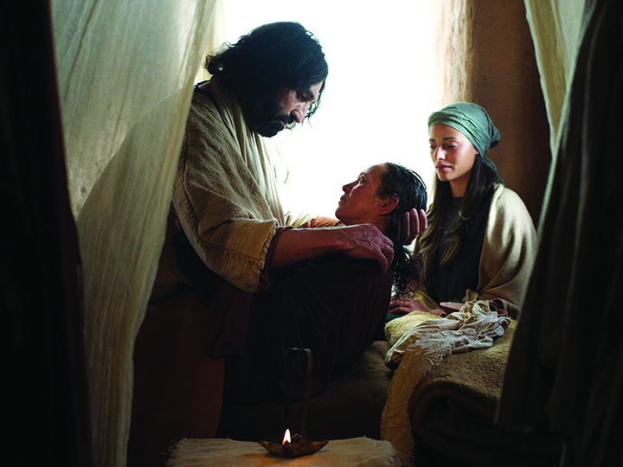

“*Jesus healed many who had various diseases. He also drove out many demons, but he would not let the demons speak because they knew who he was.”*

Mark 1:34

***Lord hear us as we pray,***

**For a just and lasting peace wherever there is war or imminent risk of war.**

**For** Your comfort and peace to be with those who have already faced the brutality of modern warfare and its consequences on innocent people. Especially at this time the people of **Ukraine, Russia, Gaza, Yemen, Myanmar and Sudan.**

**That leaders of all nations use wisdom and discernment** before determining any action which may further worsen relations between nations and across global regions, particularly at this time the Middle East.

**For the safety of the crews of merchant ships** sailing through the Red Sea as attacks on them continue, and **also for the safety of UK and allied naval vessels and their crews escorting those merchant vessels.**

**For the millions of Christians around our world in so many countries who face arrest, imprisonment torture and even death, simply for proclaiming You as their Lord and Saviour.**

**From the World Watch List of 2023, issued by Open Doors,** we especially **pray for those in the 10 countries where reported persecution of Christians was at the highest levels last year:**

*North Korea*

*Somalia*

*Yemen*

*Eritrea*

*Libya*

*Nigeria*

*Pakistan*

*Iran*

*Afghanistan*

***Lord hear us as we pray,***

* For the leaders of Churches across our nation and here in Lancashire for our Bishops Philip and Jill.
* For all the Clergy of our Church and their families**,** for our Vicar Dave, for L J and for David in his Associated Ministry with us. For Steve and Lisa, for their Ministry in our Church and in India.
* For Nicola our Church Warden in all she does in her role & in our community.
* For our LLM’s and ALM’s and those who have a ministry with the sick, the homeless and housebound.
* For Marlis in her missionary work overseas.
* For Denise in her ministry in Urban Mission.

**For those who will be with us at our Church for the first tim**e in the coming week, that they may know God’s loving presence and peace and accept Jesus into their lives as their Saviour and Redeemer.

***Lord hear us as we pray,***

**For all those is positions of power** and leadership across our nation in national government, in parliament and in our local council here in Blackpool.

**For our emergency service workers**, police, ambulance, fire & rescue, HM Coastguard. Lord protect them in the course of their duties protecting us.

F**or all who were injured and those who witnessed the horrific chemical attack in Clapham on a defenceless woman and her children** – We also pray for those who came to their aid and those in our NHS who are providing medical and psychological care for the victims.

**For our NHS and Social Workers** at the front line of helping those suffering acute physical or mental health crises across our nation.

**For all who volunteer or work overseas**, especially in those areas of our world where there is conflict or severe personal danger to them.

**For our Armed Forces** – Especially at this time of high alert for NATO member states, including the UK with deployment to guard NATO borders with Russia.