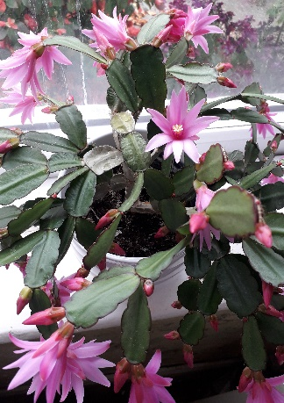
Thank you so much to all those who helped in any way to make the Jacob’s Join last Sunday after the morning service so good as a celebration of Revd Dave’s birthday. In terms of presents, I think it is true to say that he has more than enough custard now to see him through to his next birthday !!
Thank you also to everyone for the support given for the Annual Parochial Church Meeting (AGM) last Monday. The new PCC met afterwards. The list of PCC memebrs will be posted on the noticeboard.
(the photo on the left is of my Easter Cactus)
A DATE FOR YOUR DIARY – Saturday 28th May – in church an event called ‘Wonder Day’. There will be activities and things to look at and explore as we think about different aspects of faith and science. Volunteers needed please for this event. Please have a chat to Emma.

Services for the coming weeks shown below.
Key : CB: Chris Blazey; YB: Yvonne Blazey; SH: Revd Steve Haskett; IL: Irene Leak; DOB: Revd Dave O’Brien; ES: Revd Emma Swarbrick
SUNDAY | 10.30am Intergenerational Service | 6pm Worship, Prayer and Bible Teaching | For you to read through the week PSALMS
1st May  EASTER 3 | Service of the Word  Theme:  John 21: 1 - 19  Preach: SH  Lead: DOB | Holy Communion  Theme:  John 21: 1 – 19  Preach: ES  Lead: DOB | Mon 139, 146  Tues 98  Wed 105  Thurs 136  Fri 107  Sat 110
8th May  EASTER 4 | Holy Communion  Theme:  John 10: 22 – 30  Preach: ES  Lead: DOB | Service of the Word  Theme:  John 10: 22 – 30  Preach: CB  Lead: YB | From today:  3 – 4pm Children’s Bible Study and 4 – 5pm Family Celebration
15th May  EASTER 5 | Service of the Word  Theme:  John 13: 31 – 35  Preach: DOB  Lead: ES | Holy Communion  Theme:  John 13: 31 – 35  Preach: IL  Lead: SH
22nd May  EASTER 6 | Holy Communion  Theme:  John 5: 1 – 9  Preach: SH  Lead: ES | Service of the Word  Theme:  John 5: 1 – 9  Preach: ES  Lead: SH
29th May  EASTER 7  Prayer for healing during the services | Service of the Word  Theme:  John 17: 20 – end  Preach: ES  Lead: SH | Holy Communion  Theme:  John 17: 20 – end  Preach: CB  Lead: SH
5th June  PENTECOST | Holy Communion  Theme:  Acts 2: 1 – 21  Preach: SH  Lead: ES | Service of the Word  Theme:  Acts 2: 1 – 21  Preach: DOB  Lead: SH
12th June  TRINITY SUNDAY | Service of the Word  Theme:  John 16: 12 - 15  Preach: DOB  Lead: ES | Holy Communion  Theme:  John 16: 12 – 15  Preach: YB  Lead DOB

Midweek (Wed.) Book of Common Prayer Holy Communion Service:
4th May | John 21: 1 – 19 Lead/Celebrant: ES Preach: DOB
11th May | John 10: 22 – 30 Lead/Celebrant: DOB Preach: ES
18th May | John 13: 31 – 35 Lead/Celebrant: ES Preach: DOB
25th May | John 5: 1 – 9 Lead/Celebrant: DOB Preach: YB
1st June | John 17: 20 – end Lead/Celebrant: DOB Preach: ES

(the LORD said…) Now my eyes will be open and my ears attentive to the prayers offered in this place. (2 Chron, 7: 15)

