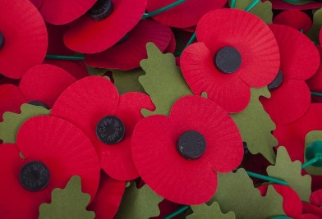
(picture taken from the Church of England website for Remembrance Sunday)

A prayer for World peace
O God of the nations,
as we look to that day when you will gather people from north and south, east and west,
into the unity of your peaceable Kingdom,
guide with your just and gentle wisdom all who take counsel
for the nations of the world, that all your people may spend their days in security, freedom, and peace, through Jesus Christ, our Lord. Amen.

Jack Hull, a life-long member of St Thomas’ Church, a beloved brother in our church family, died this last week. More details will be published when the funeral arrangements are known. Please use the prayers in our Prayer Letter.

A reminder of the running total for Gift Day 2022 which currently stands at:
£ 4,837
Let’s give glory to our God, who gives to us out of His abundance and grace.

If you want to know anything about what is coming up at St Thomas’ please do ask Revd Dave or Pauline, our churchwarden.

Psalms for each day of the week 14th – 19th November:
Mon: Psalm 47 Tues: Psalm 52 Wed: Psalm 56
Thurs: Psalm 62 Fri: Psalm 63 Sat: Psalm 78 v 1 - 39
The services for the coming weeks given opposite.
Key: DOB: Revd Dave O’Brien; SH: Revd Steve Haskett; DW: Revd David Wilkinson; VB: Vicky Bentley (LLM); YB: Yvonne Blazey (LLM);
CB: Chris Blazey
Holy Communion Service of the Word

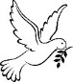
Prayers for healing
during the service
SUNDAY | 10.30am | 6pm
13th Nov.  2nd Sunday before Advent | 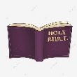  Luke 21: 5 - 19  REMEMBRANCE SUNDAY  Preach: DOB  Lead: DOB | Worship and Bible Teaching  Daniel 7: 1 – 14  The Conquering King  Preach: DOB  Lead: VB
20th Nov.  CHRIST THE KING  Sunday before Advent | Luke 19:  1 – 10  Preach: SH  Lead: DOB  Life Association presentation | 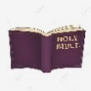  Intercessory Prayer for Healing  Luke 23: 22 – 43 The Crucified King  Preach: DOB  Lead: VB
27th Nov.  ADVENT 1 | Matthew 24:  36 – 44  Preach: DOB  Lead: YB | Worship and Bible Teaching  Matthew 24:  36 – 44  The Coming King  Preach: VB  Lead: DOB
4th Dec.  ADVENT 2 | Matthew 3: 1 -12  Preach: VB  Lead: DOB | 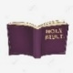  Prayer and Worship Gathering  Intercessory Prayer  Luke 1: 46 – 55  The Humble King  Preach: CB  Lead: DOB
Midweek (Wed.) Book of Common Prayer Holy Communion Service:
16th Nov. | Luke 21: 5 – 19 Lead/Celebrant: DOB Preach: YB
23rd Nov. | Luke 23: 33 – 43 Lead/Celebrant: DW Preach: VB
30th Nov. St Andrew | Matthew 24: 36 – 44 Lead/Preach/Celebrant: DOB
7th Dec. | Matthew 3: 1 – 12 Lead/Celebrant: DOB Preach: YB

