

***Lord God, whose Son, Jesus Christ,***  
**understood people's fear and pain before they spoke of them,**we pray for those in hospital and at home;  
surround the frightened with Your tenderness;  
give strength to those in pain;  
hold the weak in Your arms of love, and give hope and patience  
to those who are recovering;

we ask this through the same Jesus Christ, our Lord. **Amen.**

***Prayer Letter***

***Easter Day***

Lord, pour out Your Holy Spirit upon us and may Your light so shine through us that together we share Your love with everyone and by Your power turn the tide of evil that surrounds us, through Jesus Christ our Lord. **Amen.**

*Our Prayer Letter includes prayers from the Church of England Common Worship and website.*

***"The Lord bless you and keep you.***

***The Lord make His face shine upon you and be gracious to you.***

***The Lord turn His face to you and give you His peace."***

**Numbers 6: 24-26**

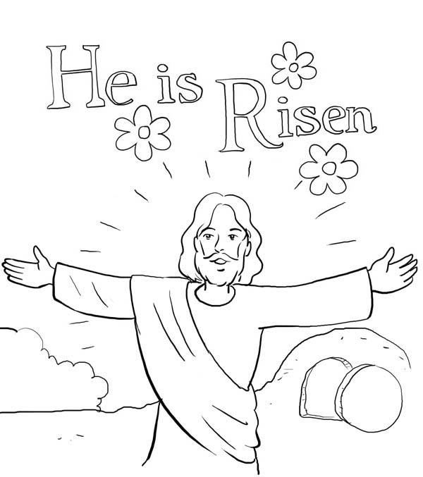

***Lord, hear me as I pray;***

For Sue, Sarah, Sheila, Jack, Leah, Marion, Louise, Debbie, Stephen, Ann, Mary & Keith, Irene, Nic & Joanne, Norman & Jean, Anne & Ian.

For all those we know personally who are ill or struggling at this time in body, mind or spirit.

For all who have recently been bereaved.

*That they may be given comfort and strength in their grief and loss, in the knowledge of Your victory over death, the sins of the world and the devil as we celebrate your Glorious Resurrection on Easter Day.*

***He is Risen - He is Risen Indeed Hallelujah!***

17th April 2022

***.”***

***Let us pray for the church, the world and ourselves and let us thank God for His goodness:***

For all fleeing war and persecution as refugees and asylum seekers. That they are treated with the dignity, respect, fairness and compassion which

we hope would be offered to us if ever we were to find ourselves in their shoes.

Lord God, we ask that you protect all who work for peace in our troubled world. We pray for all those whose lives have been affected by war and the consequences of war.

**Yemen**, where war has been ongoing for many years.

**Afghanistan**, where there is suffering from malnutrition.

**Ukraine,**  We pray that there will soon be and end to the horrific war in Ukraine and that the people of Ukraine and Russia will one day be able to

live in peace and reconciliation, free from oppression, war and persecution.

***For The Church & our witness to the Gospel***

**Lord, we pray :**

For our Bishops Julian, Philip and Jill; giving thanks especially for Bishop Julian as he has announced he will be retiring in the summer.

For our Vicar Dave, for Alison and Josh.

For our Curate Emma in her continuing ministry with our Church and as she prepares for her new position in the parish of Lytham, to work as a mission enabler this Summer.

For Revd Steve and Lisa, for the work of Life Association in India, for all our brothers and sisters there, for the work of mission and care.

For Matt and everyone involved in the work with children and young people.

For all who attend our church, that they are safe and renewed in the knowledge and belief in your promise that you are the God of love and forgiveness by your sacrifice for our sins on the Cross of Salvation.

***"I write these things to you who believe in the name of the Son of God so that you may know that you have eternal life****."*

**1 John 5:13**

***Lord, hear me as I pray;***

For our community, for all the people who live and work around us.

For Devonshire Primary Academy: teachers, other staff, children, parents, grandparents and carers.

For all in our community whose lives are impacted by mental health difficulties, chronic pain, illness or disability.

For all in need of help with any personal, financial or social issues they are struggling to cope with at this difficult time for so many – That they may access the help and support they need to overcome their difficulties.

***Lord, hear me as I pray;***

Give wisdom to all in authority especially Elizabeth, our Queen. We thank You Lord God for her life of service and her faith in Jesus Christ.

For all those is position of power across all Governments – national, regional and local – Grant them integrity, compassion and wisdom in their decision making and strength of purpose for our common good and for that of the entire world. **Amen.**

**In this time of tumults;**

**O ALMIGHTY God**, King of all kings, and Governor of all things, whose power no creature is able to resist, to whom it belongeth justly to punish sinners, and to be merciful to them that truly repent: Save and deliver us, we humbly beseech thee, from the hands of our enemies; abate their pride, asswage their malice, and confound their devices; that we, being armed with thy defence, may be preserved evermore from all perils, to glorify thee, who art the only giver of all victory; through the merits of thy only Son, Jesus Christ our Lord. **Amen.**