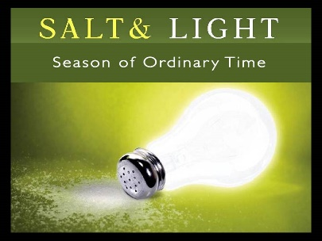
We welcome Bishop Jill to our 10.30am Holy Communion Service this morning.
Is it a God-incidence that one of the Bible readings is from Matthew 5 from verse 13 about being salt and light? ….. You may be aware that several lights in church have needed replacing for some time. We have been waiting for the supplies and the contractor to become available. However, there is a promise that the contractor will start working to replace the lights this coming week, which will mean that scaffolding will be erected in church, but Sunday services should not be affected. The new lights will be warm light LEDs. Many thanks to Pauline, our churchwarden, for her patience and perseverance.

Events to look forward to this year:
MARCH – Science and Wonder Day and the Riding Lights Theatre Co.
APRIL – 7th April GOOD FRIDAY and 9th April EASTER DAY celebrations
29th Street visits, BBQ and Fun Day
Sunday 30th George and Joan Fisher at 10.30am and 6pm services

WOULD YOU LIKE A TRIP OUT TO BURY MARKET? – a day trip is being planned for Friday 19th May. If you are interested in going, please have a word with Pauline.

Psalms for each day of the week 6th – 11th February:
Mon: Psalm 30 Tues: Psalm 36 Wed: Psalm 34
Thurs: Psalm 37 Fri: Psalm 31 Sat: Psalms 41, 42, 43

The services for the coming weeks are given below.
Key: DOB: Revd Dave O’Brien; YB: Yvonne Blazey; VB: Vicky Bentley
DW: Revd David Wilkinson; TH: Thomas Henley; CB: Chris Blazey


Holy Communion Service of the Word
SUNDAY | 10.30am | 6pm
5th Feb  3rd Before Lent |   Theme:  Colossians 1.1-14  Matthew 5. 13-20  Lead: DOB  Preach: Bishop Jill | Theme:  Ezekiel 37.1-14  The Promise of Revival  Lead: DOB  Preach: CB
12th Feb  2nd Before Lent | Teaching series on Colossians  Colossians 1: 15 – 23  Matthew 6: 25 – end  Lead: DOB  Preach: DW |   Theme:  Acts 4: 23 – 31  The Promise of Power  ‘The Prayer that Shakes’  Lead: VB  Preach: YB
19th Feb  Sunday before Lent | Theme  Colossians 1:  24 –end; 2: 1 – 5  Matthew 17: 1 – 9  Lead: YB  Preach: DOB | Theme:  Luke 11: 1 – 13  The Promise of  Answered Prayer  Lead: DOB  Preach: DW
22nd Feb  ASH WEDNESDAY | Evening Service of Holy Communion and Ashing  7pm  Theme: Joel 2: 1 – 2, 12 – 17;  Matthew 6 : 1 – 18  Lead/Preach: DOB
Midweek Book of Common Prayer Holy Communion Service:
8th February  Mark 7: 14 – 23  Lead: DOB Preach: YB | 22nd February ASH WEDNESDAY  John 8: 1 – 11  Lead/Preach: DOB
15th February  Mark 8: 22 – 26  Lead: DOB Preach: TH | 1st March  Mark 4: 26 – 32  Lead: DW Preach: VB

