

* ***Lord of comfort and peace we bring before you all who are struggling with infirmity or pain in body, mind or spirit;***

for Sarah, Jack, Leah, Debbie, Stephen, Richard, Norman and Jean, Anne and Ian and all who we know by name who are suffering at this time.

* ***Lord of comfort and peace, we ask that you be with all those who suffer pain and anguish in bereavement;***

**Amen**

***"The Lord bless you and keep you.***

***The Lord make His face shine upon you and be gracious to you.***

***The Lord turn His face to you and give you His peace."***

**Numbers 6: 24-26**

**Prayer Letter**

30th October 2022

All Saints

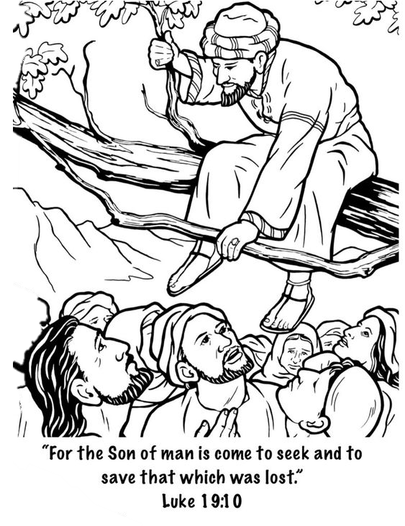

***Lord hear us as we pray,***

**for the people of Ukraine and** **Russia** – that the futility and madness of the war raged on the people of Ukraine will come to an end without further loss of life, loss of home, loss of security, loss of all that people hold dear.

**for continued strength, unity and wisdom** amongst the leaders of nations, particularly those which are members of NATO, especially at this time to deter wider escalation of the war by Russian forces.

**for lasting solutions to be found** to the many situations around our world where there are conflicts and risks of conflicts between nations and within nations. Especially at this time for the people of the Korean Peninsula, Japan and Taiwan.

**for the people of Somalia** and other nations across the Horn of Africa facing starvation due to the impact of two years of drought, and their predicament worsened further by the theft of cereal crops from their meagre harvest by Al Shabab militant forces terrorising them.

**for the people of Iran,** that their protests lead to a peacefulend to the totalitarian rule of their nation and the establishments of rights and freedoms and an end to oppression, torture and death at the hands of the powerful.

**For the people of Myanmar** where the military junta are carrying out indiscriminate air strikes on their own civilians and where oppression of minority groups and political opponents continues.

**for those affected by violence, injustice and oppression** for all persecuted for their faith. From the World Watch List 2022 issued by Open Doors, we pray for the 10 countries where persecution is worst – Afghanistan, North Korea, Somalia, Libya, Yemen, Eritrea, Nigeria, Pakistan, Iran, India. Remembering that nearly 6,000 Christians were murdered for their faith last year.

**We pray for the millions of Christians around our world** who face arrest, imprisonment torture and even death, simply for proclaiming You as their Lord and Saviour.

***Lord hear us as we pray,***

for all Church leaders across our nation, and in our community. In our parish for our Vicar Dave and for the work of Alison through Ashar and those attending Starting Point on Monday afternoons.

for Steve and Lisa currently in India – God, give them all that they need and lead them to life-giving, hope-filled conversations with many.

for Matt and Rosie and everyone involved in helping in Matt's ministry.

forThomaswho has joined us on placement with the Blackpool Ministry Experience.

for our Worship group in all they do both in their preparation and practice and in leading us in worship and praise through their music and singing.

for those who give their time in service to make our church a welcoming and peaceful place for worship.

for all who attend our Church, that they may know your loving presence and accept You into their lives, knowing your love and forgiveness for each them.

***Lord hear us as we pray,***

**for all those is positions of power** and leadership in our country. We ask You, O God, to raise up men and women of faith and integrity in every democratic political party, to justly represent the people of our nation in parliament and in local and devolved government.

**for our Emergency Services**, Armed Forces and Frontline NHS and Social Workers and all who volunteer to help others in need.

**for all who are anxious about** the financial and political situations across the United Kingdom and for the people of Northern Ireland who may be fearful due to the political tensions which have re-emerged in recent times.