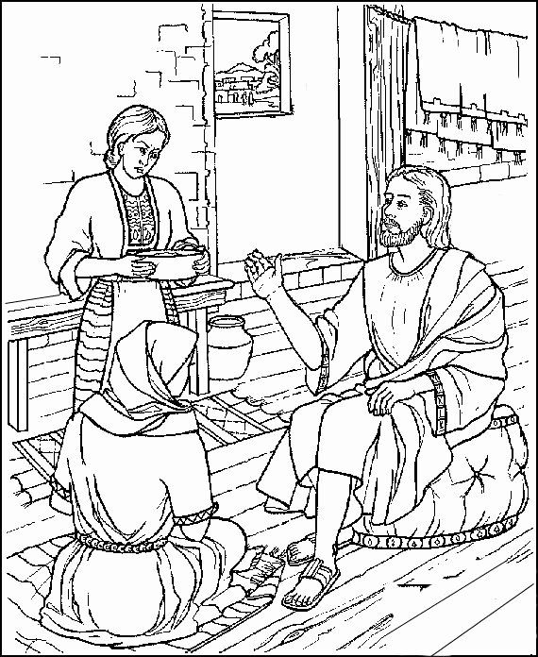

**Prayer Letter**

5th Sunday after Trinity : 17th July 2022

As Jesus and his disciples were on their way, he came to a village where a woman named Martha opened her home to him.  She had a sister called Mary, who sat at the Lord’s feet listening to what he said.  But Martha was distracted by all the preparations that had to be made. She came to him and asked, “Lord, don’t you care that my sister has left me to do the work by myself? Tell her to help me!” *"****Martha, Martha,” the Lord answered, “you are worried and upset about many things, but few things are needed—or indeed only one.  Mary has chosen what is better, and it will not be taken away from her.”***

***Luke 10: 38-42***

***"The Lord bless you and keep you.***

***The Lord make His face shine upon you and be gracious to you.***

***The Lord turn His face to you and give you His peace."***

**Numbers 6: 24-26**

* ***Lord of comfort and peace, we ask that you be with all those who suffer pain and anguish in bereavement; and for all who are struggling with infirmity or pain in body, mind or spirit.***

For those in hospital and at home;  
surround the frightened with Your tenderness;  
give strength to those in pain;  
hold the weak in Your arms of love, and give hope and patience  
to those who are recovering.

***We bring before you now:***

Audrey, Sue, Sarah, Leah, Gordon, Louise, Debbie, Stephen, Norman and Jean, Anne and Ian.

Thank you, Jesus. **Amen**

***Lord God hear me as we pray,***

**Ukraine,**  For peace and an end to the senseless atrocities and deaths caused by the indiscriminate and brutal actions of Russian forces against innocent civilians, including the deaths of so many children.

For the people of Sri Lanka as the economic and political crisis in that nation continues

**Refugees and asylum seekers,** we continue to pray that there are fair and just solutions to the current issues relating to the refugee and asylum seekers both in our nation and around our world.

**For the people of western Europe,** including in our nation, as severe risk to life warnings are issued due to the unprecedented temperatures being faced in the coming week. Also for all who will be providing support and information to protect life during the heat wave.

In this Your beautiful but fragile world which You created for us to be stewards of, bless all who dedicate their lives to its care, and to all who within their hearts and in their minds and bodies have the passion skills and energy to protect its climate, oceans, forests, plants and creatures for us and all future generations.

***Amen***

------------------------------------------------------------------------------------------

**For all who work in our schools, colleges and universities** and other places of learning across our town and around our country as the summer term comes to an end in the coming week. Keep all children and young people safe as they enjoy time away from their work and studies during the coming months.

**For people of all ages and** **abilities** who are learning new skills through formal or informal education to enable them to enjoy fulfilling life experiences.

**For all who serve as elected members on Blackpool Borough Council**, and for all who work to provide us with the public services we receive across our borough.

***Lord, God hear me as we pray,***

For The Christian leaders in every Church and Diocese across our nation.

For our Vicar Dave, for Alison and Josh. Also for the work of Ashar and those attending Starting Point.

For Steve and Lisa in their mission with the poor in India and in our Parish

For Emma as she ends her time with us and begins her new Ministry in Lytham. We thank you for all her love and devotion to her mission in our Church, to us and for the people of our parish in her service to You.

For Matt and everyone involved in the work with children and young people.

For all who attend our Church, that they may be safe in the knowledge of Your forgiveness and love for each of them.

***.”***

***Lord God, here me as we pray,***

For Elizabeth, our Queen. We thank You Lord God for her long life of service and her faith in Jesus Christ which is an inspiration to us all.

For all those is position of power and leadership in every political party in Parliament and in local or devolved Government across the nations of the United Kingdom.

We also pray at this time for who will be contesting the leadership of the Conservative Party as they aspire to become the next Prime Minister of our nation.

For our Emergency Services, Armed Forces and Frontline NHS and Social Workers. Also for all who give their time as volunteers in service to help others.