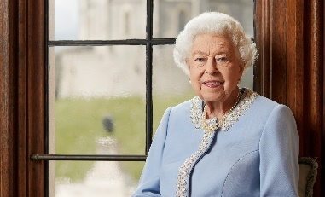
As this Newsletter is being produced, we await the state funeral of Queen Elizabeth II, which will take place on Monday 19th September, declared a Bank Holiday.
Today, Sunday 18th September, there is a County Service of Thanksgiving at Blackburn Cathedral at 2pm, which will be livestreamed.
The recently retired Bishop of Blackburn, Rt Rev Julian Henderson, has written a prayer for use at this time:
We come to you, our everlasting God, at a time of change and sadness, following the death of our Sovereign Lady Queen Elizabeth.
Your call to her and Your anointing of her 70-year reign have been a blessing to this nation and around the world.
We bring our thanks to You for a life of dutiful and willing service right to the end and a life of active faith and hope in Jesus Christ.
We ask for Your comfort and strength for her family as they grieve and take on new responsibilities.
Guide the King as a different era unfolds and may the days that lie ahead build on the legacy of that which has gone before and promote faith, justice and peace in our land, through Jesus Christ our Lord and Saviour. Amen.

Psalms for each day of the week 19th – 24th September :
Mon: Psalm 1 Tues: Psalm 5 Wed (Matthew, Apostle and Evangelist): Psalm 49 Thurs: Psalm 15 Fri: Psalm 19 Sat: Psalm 23
The services for the coming weeks given opposite.
Key: CB: Chris Blazey; YB: Yvonne Blazey; SH: Revd Steve Haskett; DOB: Revd Dave O’Brien; VB: Vicky Bentley
Holy Communion Service of the Word

Prayers for healing Children’s Bible Study
during the service & Family Worship

SUNDAY | 10.30am | 3 – 4pm and  4 - 5pm | 6pm
18th Sept.  Trinity 14 | Luke 16:  1 - 13  Preach: DOB  Lead: VB |  | 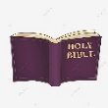  Healing Service  Luke 9:  46 – 50  Preach: VB  Lead: DOB
25th Sept.  Trinity 15 | Luke 16: 19 - end  Preach: CB  Lead: SH |  | Worship and  Bible Teaching  Luke 10: 1 – 9  Preach: YB  Lead: SH
2nd Oct.  Trinity 16  GIFT DAY/  HARVEST | 2 Cor. 9:  6 – 15  Preach: VB  Lead: DOB |  | Prayer and Worship Focus  2 Cor. 9: 6 – 15  Preach: DOB  Lead: DOB
9th Oct.  Trinity 17 | Luke 17:  5 – 19  Preach: CB  Lead: DOB |  | Worship and Bible Teaching  Focus  Revelation: 19: 1 – 10  Prophecy v 10  Preach: YB  Lead: VB
Midweek (Wed.) Book of Common Prayer Holy Communion Service:
21st Sept. | Luke 16: 1 – 13 Lead/Celebrate: DOB Preach: VB
28th Sept. | Luke 16: 19 – end Lead/Celebrate/Preach: David Wilkinson

