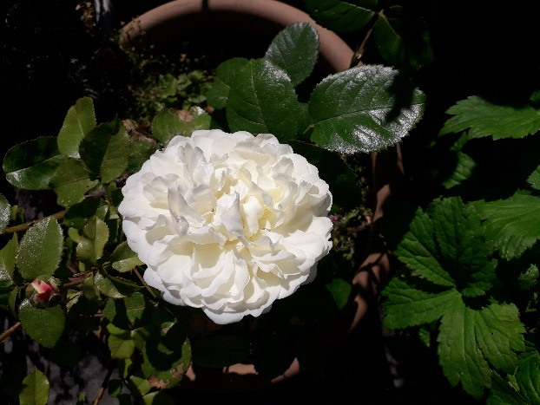
(This Old English rose is called ‘Tranquillity’)

John 15: 1 – 17 The vine and the branches
(Jesus said) “I am the true vine, and my Father is the gardener. He cuts off every branch in me that bears no fruit, while every branch that does bear fruit He prunes (or cleans) so that it will be even more fruitful.” (v 1 – 2 NIV)
“I am the vine; you are the branches. If you remain in Me and I in you, you will bear much fruit; apart from Me you can do nothing.” (v 5 NIV)
The Blackburn Diocese has launched the Vine Community – with the focus on ‘Abide, Grow, Bear Fruit’. If you would like to know more please talk with Denise (Moorby) or you can look at the leaflets at the back of church or go onto the Diocesan website and look up the Vine Community.

A Collect for Trinity 4 (10th July):
Gracious Father,
by the obedience of Jesus, you brought salvation to our wayward world:
draw us into harmony with your will, that we may find all things restored
in him, our Saviour Jesus Christ. Amen.

The services for the coming weeks given on the opposite page.
Key: CB: Chris Blazey; YB: Yvonne Blazey; SH: Revd Steve Haskett; DOB: Revd Dave O’Brien; ES: Revd Emma Swarbrick


Holy Communion Service of the Word



Prayers for healing Children’s Bible Study
during the service & Family Worship
Each SUNDAY | 10.30am Intergenerational Service | 3 – 4pm Children’s Bible Study  4 – 5pm Family Worship |  | 6pm Worship, Prayer and Bible Teaching
SUNDAY | 10.30am |  | 3 – 4pm and  4 - 5pm |  | 6pm
10th July  Trinity 4 |   Luke 10: 25 – 37  Preach: ES  Lead: SH |  |  |  |   Luke 10: 25 – 37  Preach: DOB  Lead: DOB
17th July  Trinity 5  Emma’s Farewell Sunday | Luke 10: 38 – end  Preach: DOB  Lead: ES |  |  |  | Luke 10: 38 – end  Preach: ES  Lead: DOB
24th July  Trinity 6 | Luke 11:  1 – 13  Preach: CB  Lead: DOB |  |  |  | Luke 11:  1 – 13  Preach: DOB  Lead: SH
31st July  Trinity 7 | Luke 12: 13 – 21  Preach: SH  Lead: DOB |  |  |  | Luke 12:  13 – 21  Preach: DOB  Lead: SH
Midweek (Wed.) Book of Common Prayer Holy Communion Service:
13th July | Luke 10: 25 – 37 Lead/Celebrant: DOB Preach: ES
20th July | Luke 10: 38 – end Lead/Celebrant: DOB Preach: YB
Midweek Communion takes a summer break after this last Wednesday

Morning Psalms for each day of the week 11th – 16th July :
Mon: Psalm 80 Tues: Psalm 89v 1 - 18 Wed: Psalms 119 v 105 - 128
Thurs: Psalm 92 Fri: Psalm 88 Sat: Psalm 97

(the LORD said…) Now my eyes will be open and my ears attentive to the prayers offered in this place. (2 Chron, 7: 15)

