
Lord of comfort, healing and peace,

- We pray for all who are struggling to cope, those affected by the breakdown of family relationships, domestic abuse and poverty .
We pray for all who are battling with addiction, or are suffering from any form of physical, emotional or spiritual oppression;
Lord of all hope, give them strength, courage and healing.

- Loving God, we ask for your blessing on all caregivers, those who give time and skills to bring hope and healing, at home, in hospitals, Care Homes and hospices.

Lord Jesus, we especially pray for all those on our Prayer Tree, those named in our service intercessions, those in our community who are ill and those we know personally who are suffering at this time.

We pray for all who are mourning the loss of a loved one:
Lord God, we pray for Your comfort and peace for all those who grieve and give us the wisdom to know how to minister to them.

"The Lord bless you and keep you.
The Lord make His face shine upon you
and be gracious to you.
The Lord turn His face to you and give you His peace."
Numbers 6: 24-26

Monthly Prayer Letter
NOVEMBER 2025

The Lord reigns, he is robed in majesty;
the Lord is robed in majesty and armed with strength;
indeed, the world is established, firm and secure.
Your throne was established long ago;
you are from all eternity. Psalm 93: 1, 2

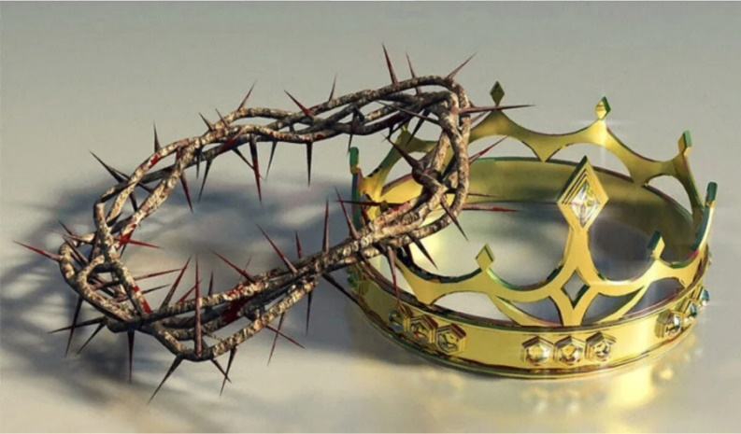
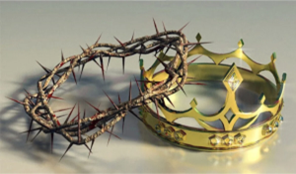

A Collect for this season:

Merciful God,
teach us to be faithful in change and uncertainty,
that trusting in your word and obeying your will
we may enter the unfailing joy of
Jesus Christ our Lord. Amen.

PRAYER TREE REQUESTS - please text John Smith on 07757 968574

Start every day’s prayer with: Lord God, hear us as we pray for………

1st Rev Steve and Lisa Haskett as they are in India with Life Association.
2nd the church services today, All Saints Day, and for Rev LJ our curate.
3rd the leadership of St Thomas’ – ordained clergy and lay volunteers.
4th Tuesday Church – all the children, families, carers and volunteers,
5th our midweek BCP Communion service.
6th Rev David and Alison Wilkinson, thanking God for their ministries among us. Pray for all who provide refreshments after our services.

The aim of this Prayer Letter is to help us pray through the month of November, day by day, holding before God the world, our parish community, events happening in the month, the church and ourselves.

17th all the members of the Parochial Church Council, the PCC secretary, Parish Safeguarding Officer, Treasurer and all who have responsibility in church.
18th for the ministry of Ashar bringing Hope.
19th all those who work in our church office, answering phone calls and emails and looking after the administration duties.
20th those who come to the warm space offered in church this afternoon with fellowship and activities. Remember in prayer our Family Engagement Worker, Nicola
21st all who work to ensure safeguarding is a priority in our church and all throughout the Diocese who work for the safety of children, young people and the vulnerable.
22nd someone we find hard to forgive or trust. Pray also for those who live on Cumbrian Avenue in our parish.
23rd Pray for Jane Atkinson today – her collation as Archdeacon of Blackburn takes place at Blackburn Cathedral at 4pm Evensong.
CHRIST THE KING SUNDAY. Pray for our services today.
24th the leaders, volunteers and those who come to Brew and a Chat this afternoon in church. Pray for listening and being heard.
25th our church cleaning team, the Holy Dusters, thanking God for their work and faithfulness to the house of the Lord.
26th those who look after the maintenance of our buildings, thanking God for their work, time and effort.
27th those bringing children for baptism and for those helping to prepare families for baptism.
28th ourselves – Heavenly Father, help us to grow in generosity of spirit, to have the mind of Christ and share Your love with all. Bring your needs before God for He cares for you.
29th our Vicar Dave as he prepares to return to parish duty after his sabbatical. Pray that God has richly blessed him in this time of being aside, may Dave have been blessed with rest and renewal. We pray too for Alison and Josh, for God’s blessings on them.
30th FIRST SUNDAY OF ADVENT – pray for our morning and evening services, all those involved in leading, preaching, intercessions and those who run the tech desk.
Thank God for the team that leads us in worship in music and song – what gifts God has given us through them.
.

Pray for a lasting peace in Gaza. Pray for Sudan that fighting and the destruction of lives will cease. Pray for Afghanistan where there is so much oppression, pray for freedom for girls and women to have access to education and training.

7th the Bereavement Group that meets this morning. Pray for all those who are grieving the loss of a loved one.
8th someone who is hurting or lonely. Pray for those who live in Caledonian Avenue in our parish.
9th REMEMBRANCE SUNDAY pray for our services today. Archdeacon David joins us for our morning service. Pray for peace in our nation; may we be peacemakers. May God bless our Prayer Ministry team.
10th those who live on Butler Street in our parish.
11th our Bishops Philip, Jill and Joe, for God’s wisdom and strength.
12th our curate, Rev LJ, asking God to give her all that she needs in her ministry and thanking Him for all He is giving to us through her.
13th the church gardening team, thanking God for their faithfulness in tending to the church grounds and allotment.
14th our churchwardens Pauline and Denise and the wardens team, our LLMs (Yvonne and Vicky) and all our ALMs in different roles.
15th a troubled situation that is on our hearts and for all those who minister in pastoral care. Pray for those who live on Campbell Avenue.
16th our church services, that the Holy Spirit would anoint every part of our worship. Accept our praises Almighty God. 2nd Sunday before Advent.

Father God, We pray that the leaders of all nations come to know the truth and turn to You and work for the peace and security of our troubled and endangered world which you gave us to be stewards over for this and all generations which may follow us. In the name of Jesus, Amen.

We pray for all those who have been and continue to be affected by the war in and around Ukraine: Lord God, bring about Your lasting and just peace, enable the rebuilding of lives and country. Bring Your healing by the power of Your Holy Spirit. In Jesus’ name. Amen,.

